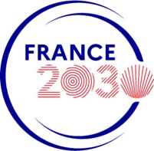
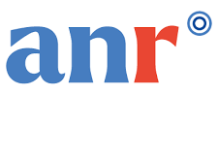

Projet « Compétences et Métiers d’Avenir » QuanTEdu-France

2024 Call – « PhD fellowship »

Thesis general informations

Project acronym: Please give the acronym of the PhD project

Thesis title: Please enter the title of the PhD project.

Expected starting date: Please specify the PhD expected starting date.

Doctoral school: Please specify the related doctoral school.

Supervisors: Please fill the following table.

 | Supervisor in Montpellier | Supervisor in Toulouse
Family Name
First name
Laboratory
Email address
Phone number

Relevant topics: Please fill the following table.

Topics | Relevance (Yes/No)
Quantum computation
Quantum communications
Quantum sensing
Quantum simulation

Summary of the PhD project: Summarize the PhD project (20 lines max).

Part 1 : Scientific program

- Scientific context
Describe the context and position the project on the international scale (half page max).

- Main scientific goals
Define the main scientific objectives of the project. Describe the innovative aspects of the project with respect to the state-of-the-art and its relevance to the call (one page max).

- Research program
Describe the proposed research program, in terms of methodology and agenda (2 pages max).

- Research impact
Describe the strategy for valorisation and dissemination of results, as well as the envisioned research outcomes in a long-term perspective (half-page max).

Part 2 : PhD Environment

- Hosting teams
Describe the scientific background of the hosting teams, in connection with the PhD program (one page max). Emphasize the nature and the benefits of the collaboration.

- CV of the supervisor(s)
Give a short CV of the PhD supervisors (half page max per CV). Give a selection of 5 publications in connection with the PhD program.

- Available facilities
Describe the available facilities in the hosting teams, required to carry the PhD work (1 page max).

